Anti-Doping Commission

TUE Application Process

The International Standard Therapeutic Use Exemptions (ISTUE) states that each National Anti-Doping Organization, International Federation and Major Event Organization must establish a clear process for applying to its TUEC for a TUE that complies with the requirements of the International Standard.

1. Obtaining a TUE
1.1 An Athlete may be granted a TUE if (and only if) he/she can show, by a balance of probability, that each of the following conditions is met:
a. The Prohibited Substance or Prohibited Method in question is needed to treat an acute or chronic medical condition, such that the Athlete would experience a significant impairment to health if the Prohibited Substance or Prohibited Method were to be withheld.
b. The Therapeutic Use of the Prohibited Substance or Prohibited Method is highly unlikely to produce any additional enhancement of performance beyond what might be anticipated by a return to the Athlete’s normal state of health following the treatment of the acute or chronic medical condition.
c. There is no reasonable Therapeutic alternative to the Use of the Prohibited Substance or Prohibited Method.
d. The necessity for the Use of the Prohibited Substance or Prohibited Method is not a consequence, wholly or in part, of the prior Use (without a TUE) of a substance or method which was prohibited at the time of such Use.

[Comment to 1.1: When a TUE-Commission is deciding whether or not to recognize a TUE granted by another Anti-Doping Organization (see ISTUE Article 7), and when WADA is reviewing a decision to grant (or not to grant) a TUE (see ISTUE Article 8), the issue will be the same as it is for a TUEC that is considering an application for a TUE under ISTUE article 6, i.e., has the Athlete demonstrated by a balance of probability that each of the conditions set out in ISTUE article 4.1 is met? The WADA documents titled “Medical Information to Support the Decisions of TUECs”, posted on WADA’s website, should be used to assist in the application of these criteria in relation to particular medical conditions.]

1.2 Unless one of the exceptions set out in ISTUE Article 4.3 applies, an Athlete who needs to Use a Prohibited Substance or Prohibited Method for Therapeutic reasons must obtain a TUE prior to Using or Possessing the substance or method in question.

1.3 An Athlete may only be granted retroactive approval for his/her Therapeutic Use of a Prohibited Substance or Prohibited Method (i.e., a retroactive TUE) if:
a. Emergency treatment or treatment of an acute medical condition was necessary; or
b. Due to other exceptional circumstances, there was insufficient time or opportunity for the Athlete to submit, or for the TUEC to consider, an application for the TUE prior to Sample collection; or
c. The applicable rules required the Athlete (see comment to ISTUE Article 5.1) or permitted the Athlete (see Code Article 4.4.5) to apply for a retroactive TUE; or

[Comment to 1.3(c): Such Athletes are strongly advised to have a medical file prepared and ready to demonstrate their satisfaction of the TUE conditions set out at ISTUE Article 4.1, in case an application for a retroactive TUE is necessary following Sample collection.]

d. It is agreed, by WADA and by the Anti-Doping Organization to whom the application for a retroactive TUE is or would be made, that fairness requires the grant of a retroactive TUE.

[Comment to ISTUE 1.3(d): If WADA and/or the Anti-Doping Organization do not agree to the application of ISTUE Article 4.3(d), that may not be challenged either as a defense to proceedings for an anti-doping rule violation, or by way of appeal, or otherwise.]

2.1 An Athlete who needs a TUE should apply as soon as possible. For substances prohibited In-Competition only, the Athlete should apply for a TUE at least 30 days before his/her next Competition, unless it is an emergency or exceptional situation. The Athlete should apply to the Aruba Anti-Doping Commission, International Federation and/or a Major Event Organization (as applicable), using the TUE application form provided.

2.2 The Athlete should submit the TUE application form to the Aruba Anti-Doping Commission or via ADAMS. The form must be accompanied by:
a. a statement by an appropriately qualified physician, attesting to the need for the Athlete to Use the Prohibited Substance or Prohibited Method in question for Therapeutic reasons; and
b. a comprehensive medical history, including documentation from the original diagnosing physician(s) (where possible) and the results of all examinations, laboratory investigations and imaging studies relevant to the application.

[Comment to 2.2 (b): The information submitted in relation to the diagnosis, treatment and duration of validity should be guided by the WADA documents titled “Medical Information to Support the Decisions of TUECs”.]

2.3 The Athlete should keep a complete copy of the TUE application form and of all materials and information submitted in support of that application.

2. 4 A TUE application will only be considered by the TUE-Commission following the receipt of a properly completed application form, accompanied by all relevant documents. Incomplete applications will be returned to the Athlete for completion and re-submission.

2.5 The TUE-Commission may request from the Athlete or his/her physician any additional information, examinations or imaging studies, or other information that it deems necessary in order to consider the Athlete’s application; and/or it may seek the assistance of such other medical or scientific experts as it deems appropriate.

2.6 Any costs incurred by the Athlete in making the TUE application and in supplementing it as required by the TUE-Commission are the responsibility of the Athlete.

2.7 The TUE-Commission shall decide whether or not to grant the application as soon as possible, and usually (i.e., unless exceptional circumstances apply) within no more than 21 days of receipt of a complete application. Where a TUE application is made a reasonable time prior to an Event, the TUE-Commission must use its best endeavors to issue its decision before the start of the Event.

2.8 The TUE-Commission’s decision must be communicated in writing to the Athlete and must be made available to WADA and to other Anti-Doping Organizations via ADAMS or any other system approved by WADA, in accordance with ISTUE Article 5.4.
a. A decision to grant a TUE must specify the dosage(s), frequency, route and duration of Administration of the Prohibited Substance or Prohibited Method in question that the TUE-Commission is permitting, reflecting the clinical circumstances, as well as any conditions imposed in connection with the TUE.
b. A decision to deny a TUE application must include an explanation of the reason(s) for the denial.

2.9 Each TUE will have a specified duration, as decided by the TUEC, at the end of which the TUE will expire automatically. If the Athlete needs to continue to Use the Prohibited Substance or Prohibited Method after the expiry date, he/she must submit an application for a new TUE well in advance of that expiry date, so that there is sufficient time for a decision to be made on the application before the expiry date.
[Comment to 6.9: The duration of validity should be guided by the WADA documents titled “Medical Information to Support the Decisions of TUE-Commission’s”.]

2.10 A TUE will be withdrawn prior to expiry if the Athlete does not promptly comply with any requirements or conditions imposed by the Anti-Doping Organization granting the TUE. Alternatively a TUE may be reversed upon review by WADA or on appeal.

2.11 Where an Adverse Analytical Finding is issued shortly after a TUE for the Prohibited Substance in question has expired or has been withdrawn or reversed, the Anti-Doping Organization conducting the initial review of the Adverse Analytical Finding (Code Article 7.2) shall consider whether the finding is consistent with Use of the Prohibited Substance prior to the expiry, withdrawal or reversal of the TUE. If so, such Use (and any resulting presence of the Prohibited Substance in the Athlete’s Sample) is not an anti-doping rule violation.

2.12 In the event that, after his/her TUE is granted, the Athlete requires a materially different dosage, frequency, route or duration of Administration of the Prohibited Substance or Prohibited Method to that specified in the TUE, he/she must apply for a new TUE. If the presence, Use, Possession or Administration of the Prohibited Substance or Prohibited Method is not consistent with the terms of the TUE granted, the fact that the Athlete has the TUE will not prevent the finding of an anti-doping rule violation.

Flow-Chart

TUE procedure if ATHLETE is NOT an International-Level Athlete when need for TUE arises.
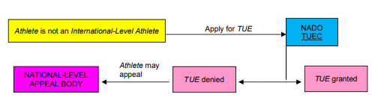
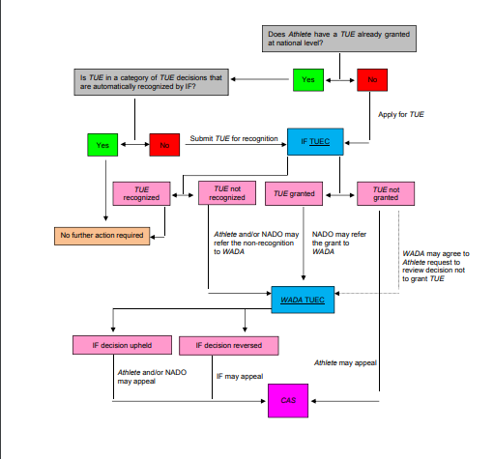
TUE procedure if ATHLETE is an International-Level Athlete (and so subject to the International Federation’s TUE requirements) when need for TUE arises.

